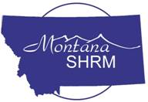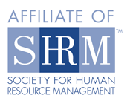

Dear SHRM Members: 4/25/12

I am pleased to announce that the SHRM Montana State Council has begun recruiting for the 2013 State Council Board of Directors.
The Montana SHRM State Council mission is to Support local Chapters in being highly successful in their assistance to members and others vested in the field; elevate the profession to the highest standards; and provide education, updates and connections among all Montana human resource professionals.
We do this by providing a structure for SHRM members to consult together concerning the affairs, activities, needs, and problems faced by the human resource management practitioners in the state. The Council serves as the communication link between SHRM and the local chapters.
We accomplish our mission through our all-volunteer board of directors and I am writing to let you know we could use your help!
If you are interested in being considered for this leadership opportunity, please submit a brief bio of your professional experience as well as your past involvement with SHRM and identify which position or positions you would like to be considered for to RMackay@mt.gov . The deadline for responding and to receive consideration for the 2012 board is October 1, 2012

If you would like a job description for any of the available positions, please visit our web site at http://montana.shrm.org/leadership and open the word document link next to the position title.

I look forward to hearing from you and encourage you to check out our website. Feel free to contact any of the specific board members about the responsibilities of their position. I am also available to discuss the individual responsibilities of each board position with you. You can reach me at 406-461-2646.

Rende L. Mackay, PHR
2011-2012 MT SHRM Council Director
2013 Nominating Committee Chair

